Grade 7 Accelerated · Unit 5 · Lessons 2–3  Scale Factor: Perimeter and Area  Independent Set 5.02 | Name______________________  Date______________________  Period____________________

Six questions, on your own, in silence. Show the step that does the work.
1. A figure with perimeter 18 cm is scaled by 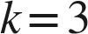. Find the copy's perimeter.

2. A figure with area 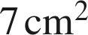 is scaled by . Find the copy's area.

3. A figure with area 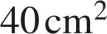 is scaled by 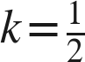. Find the copy's area.

4. A 2 cm by 5 cm rectangle is scaled by 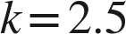. Find the copy's perimeter and area.

5. A figure has area 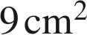 and its scale copy has area 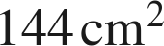. Find .

6. A figure's perimeter is 12 cm and its copy's perimeter is 48 cm. What is the area ratio, copy to original?

